**Ideation Phase**

**Brainstorm & Idea Prioritization Template**

|  |  |
| --- | --- |
| **Date** | June 30,2025 |
| **Team ID** | LTVIP2025TMID39636 |
| **Project Name** | GrainPalette - A Deep Learning Odyssey In Rice Type Classification Through Transfer Learning |
| **Maximum Marks** | 4 Marks |

Brainstorming ideas is a creative process where a group generates a list of

potential solutions, suggestions, or concepts for a specific problem or project.

Voting in brainstorming involves participants selecting and prioritizing their

favourite or most promising ideas from the list to determine which ones should

be pursued further.

### **Brainstorming for “GrainPalette - A Deep Learning Odyssey In Rice Type Classification Through Transfer Learning”.**

The primary goal of this brainstorming session is to generate innovative and practical ideas for accurately classifying rice types using deep learning and transfer learning. By leveraging advanced AI techniques, we aim to support farmers, agricultural scientists, quality control labs, food processing industries, and consumers by enabling reliable identification of rice varieties based on grain images.

This solution will help:  
1.Farmers improve crop management and pricing strategies  
2.Traders and exporters ensure correct labeling for international markets  
3.Food industries maintain product consistency  
4. Consumers get authentic rice varieties  
5.Agricultural researchers gather better data for breeding programs

**Step-1 : Team Gathering, Collaboration and Select the Problem Statement**

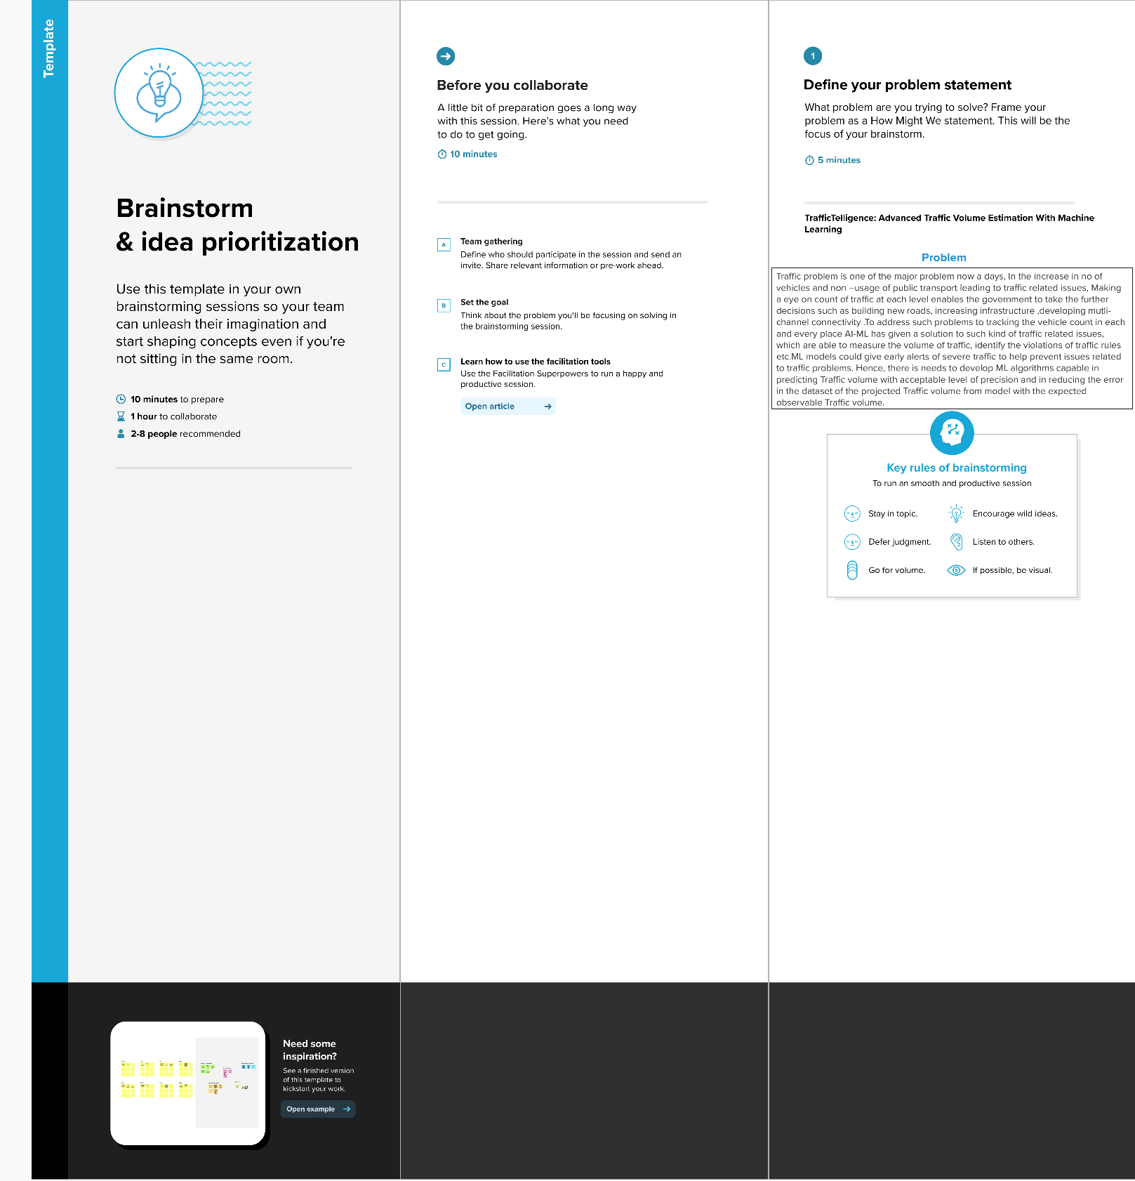

**Step-2: Brainstorm, Idea Listing and grouping**

**Step-3: Idea Prioritization**

Idea prioritization is the process of ranking or assessing ideas based on specific criteria such as feasibility, impact, cost, or strategic importance to determine which ideas should be implemented or pursued first.

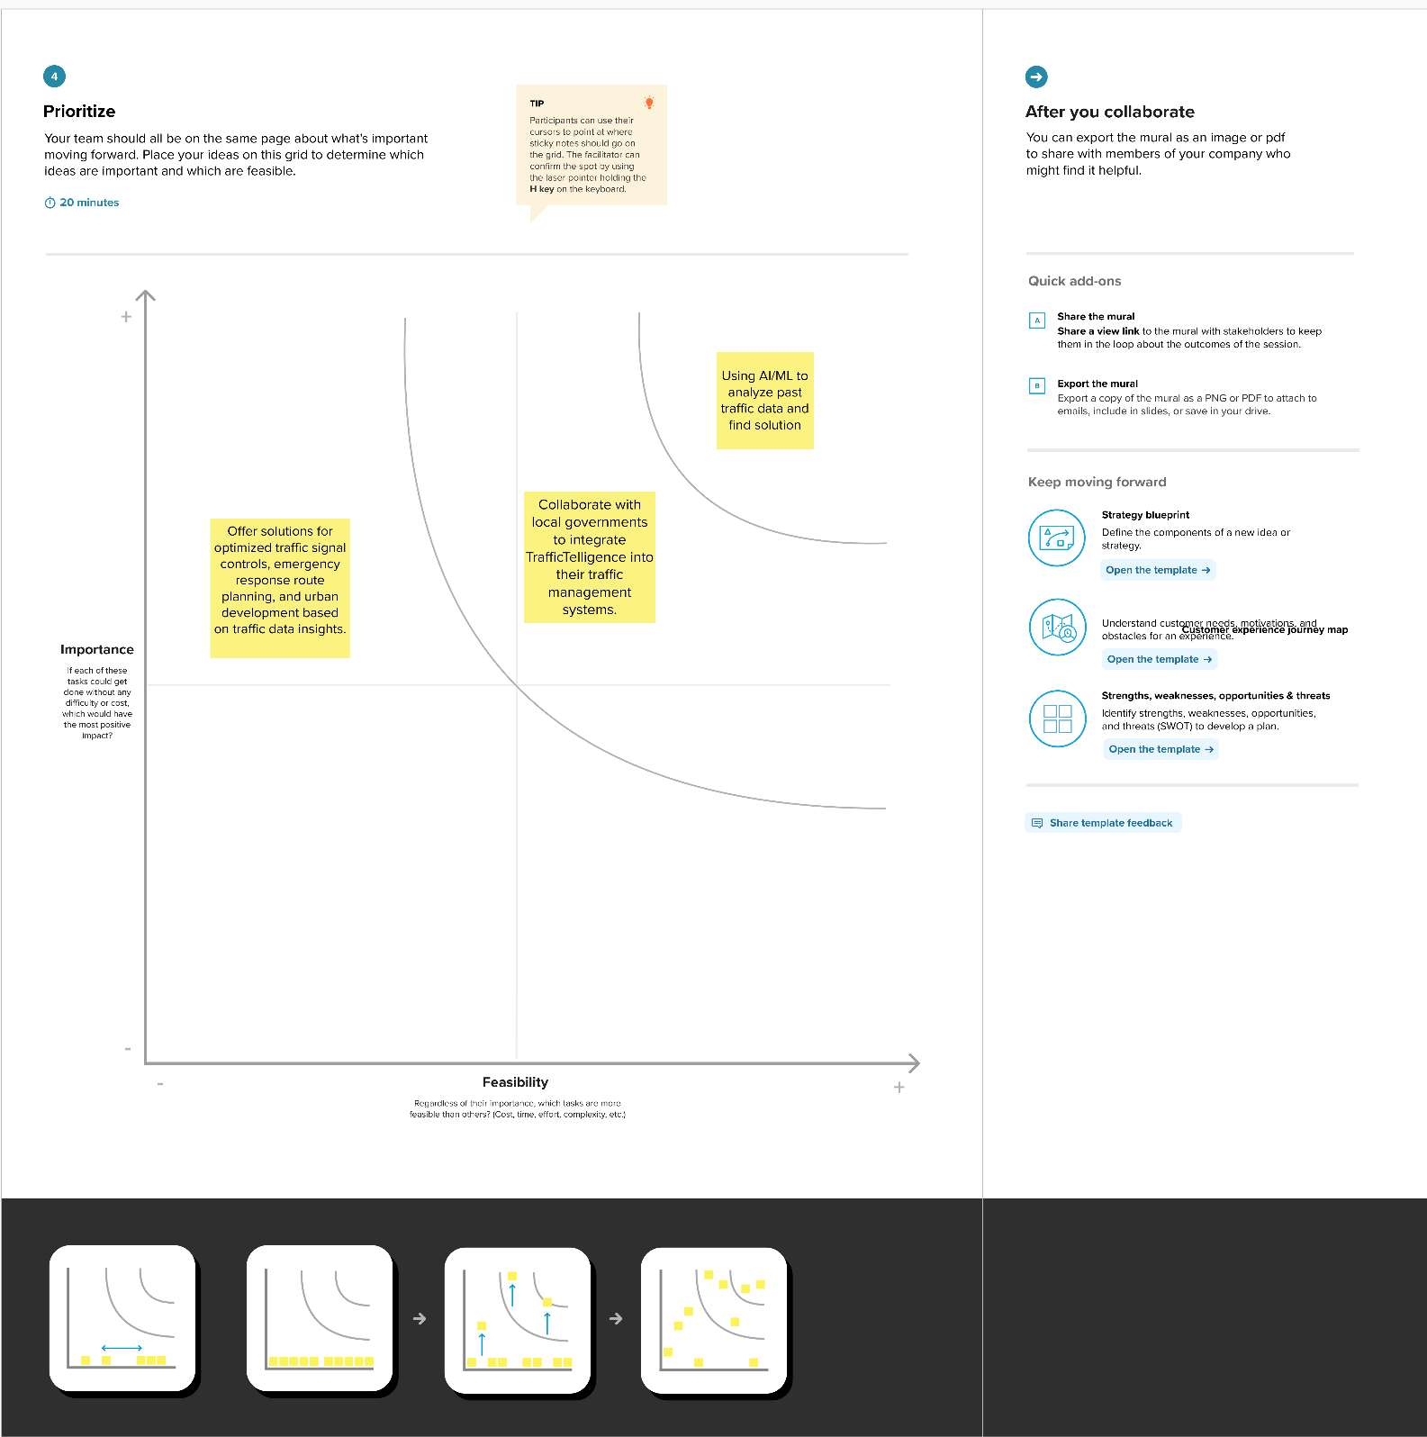

**Here certainly we chose “Using AI/ML to analyze past traffic data and find solution” is:**

Among all of other ideas this was most important to us because, if the model is not accurate enough then the prediction may not be highly accurate. So, this was our most prioritized one.

Then comes our second most important idea such as **“Collaboration with local government to integrate TrafficTelligence into their traffic management systems”**. This was taken as our second because, if we want to give ourself a social responsibility that will be helpful, not only to use but also for others. If we work with other government or organization this might be helpful for a smooth traffic without any problems for Traffic authorities and also for people.

Then comes out our next idea **“Offer solutions for optimized traffic signal controls, emergency response route planning, and urban development based on traffic data insights.”** After fulfilling our main goal, we will scale our ML model not only to predict our main problem but also for extra features such as above-mentioned things. This will give our project more value in all ways.